Use case diagram below shows some simplified view of software licensing use cases supported by Sentinel EMS Application (shown as «Application» stereotyped subject).

The Sentinel EMS handles three major workflows:

* license planning,
* order processing and production, and
* activation of trial software.

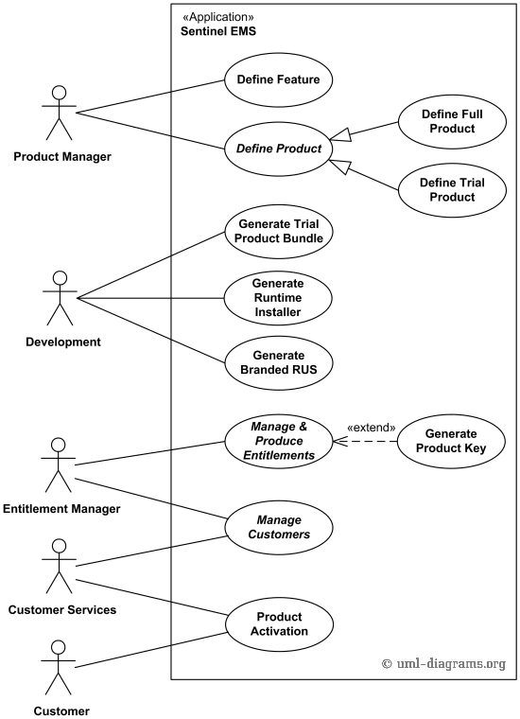

*Software licensing with Sentinel EMS application UML use case diagram example.*